# Information Visualization

# CHECKPOINT IV: First Prototype

G(14) - A

**1. Layout**

Our layout follows the sketch previously delivered and consists of six idioms: a line chart, a treemap, a grouped bars chart, a starplot, a lollipop and a slopegraph. There is also a part of the screen reserved for the controls, where, at this point, the user can only choose the political party to visualize, although he can do it directly on one of the idioms. It is not possible to unselect both political parties. The idioms which are not yet implemented are represented by an image of that idiom in our hand sketch.

As for the background colour, a white font colour made a better contrast with the treemap colours than black font colour, so, to maintain consistency, we decided to have all font colours white, which demanded a dark background. This also improves the “look and feel” of our visualization.

As for the chosen fonts, all text is Verdana san serif except for the titles which are Arial, for aesthetical reasons.

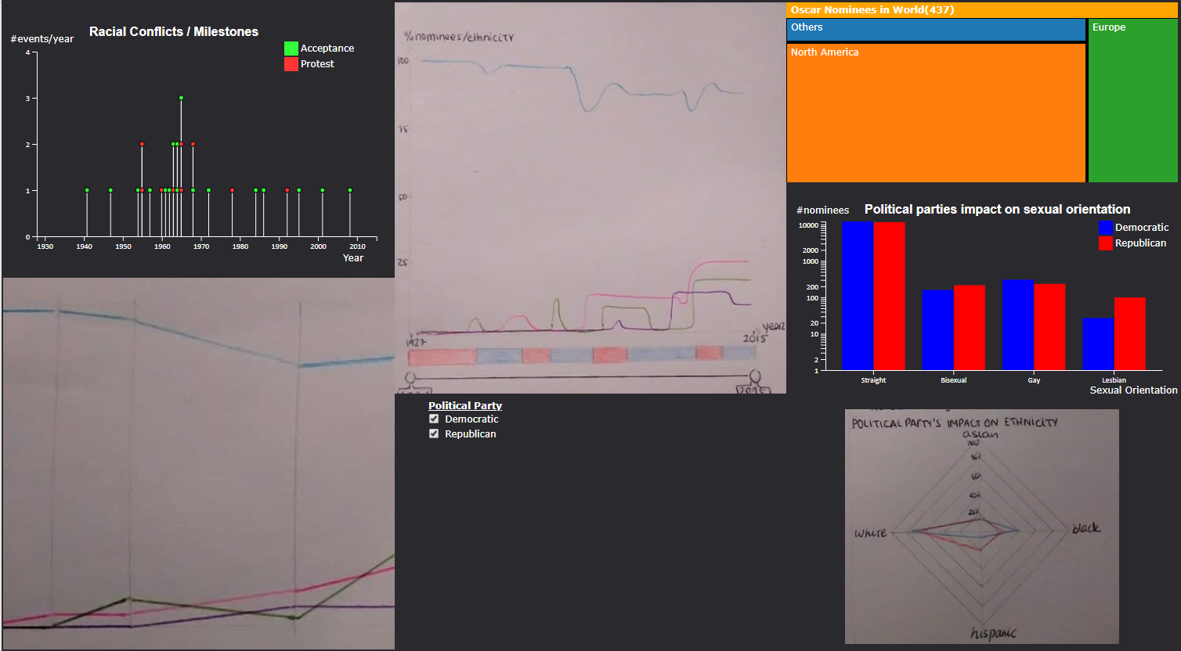  
Figure 1: Layout of our infoVis

**2. Implemented Idioms**

So far, we have implemented three of our six idioms. The only factor than can be changed is the **political party** in power in the US between “Republican” and “Democratic”. Changing the years cannot be done yet. We used **classes** to ensure the consistency between the different idioms.

We also used **animations** to smooth the transitions between states. Although the suggested time of responsiveness is 0.1 seconds, we found that to be too sudden and not smooth at all, so our animation time is 1 second.

* **Grouped bars** 
  + This idiom shows the number of winners and nominees for each sexual orientation. Clicking on one of the coloured bars or in the legend will change the party in power and affect the other idioms.
  + Although there is a rule of thumb which states that the y axis of a bar chart should always start at y = 0, this is not possible due to the use of a logarithmic scale, which is necessary because the number of straight nominees is much larger than the number of nominees with other sexual orientations.
  + Hovering over each bar shows the name of the party and the exact number encoded by that bar.
  + The Y axis resize according to the biggest value visualized

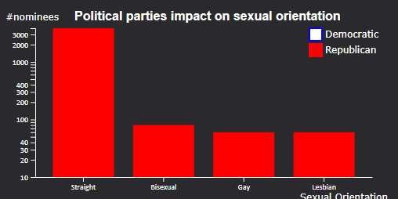  
Figure 3: Republican party selected – notice the legend of the party which is not selected

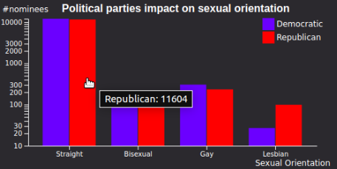  
Figure 2: Both parties selected, mouse over on first bar

* **Lollipop**
  + This idiom shows the number of racial events per year. Hovering over each circle shows the event which that circle encodes and the date.
  + 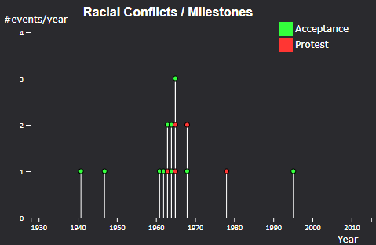This idiom changes when the political party is changed, showing only the racial events that occurred when that party was in charge.

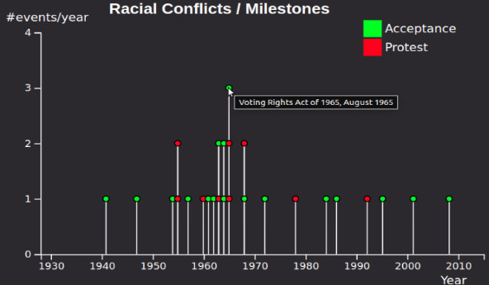

*Figure 4: Both parties selected, Figure 5: Republican party selected*

*mouse over on one milestone*

* **Treemap**
  + This idiom shows the number of winners per country, in an hierarchical way.
  + Clicking on a continent shows its countries, and clicking on the USA shows its states. It is possible to go up in the hierarchy through the top section of the treemap (“breadcrumbs”). This top section also shows the number of winners in each selected region.

  
Figure 6: "breadcrumbs" - treemap header

* + Since there is limited space and some continents have a small number of winners, these are in a section called “Others”. Expanding this section will show the remaining continents.
  + Since some countries have few numbers of winners and its full name doesn’t fit in the square that represents it, all countries are represented by an acronym.
  + Hovering over each section shows the name of the country and the number of winners from that country.
  + Since it’s easier to compare the size of squares than rectangles, the default squarified treemap is used.
  + In order to create this idiom, the csv files had to be converted to json, which is better for hierarchical data.
  + Interacting with this idiom does not change the others, but it is affected by changing the political party.

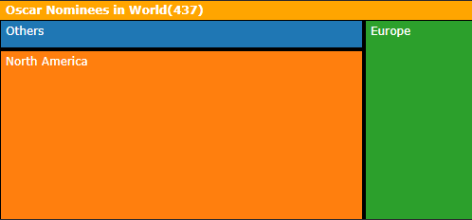  
Figure 7: Both parties selected - World

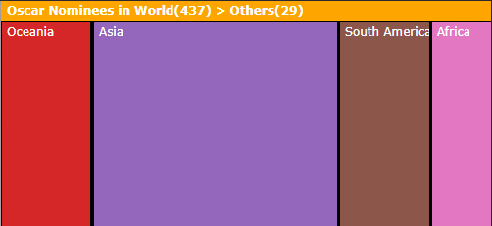  
Figure 8: Both parties selected - Others

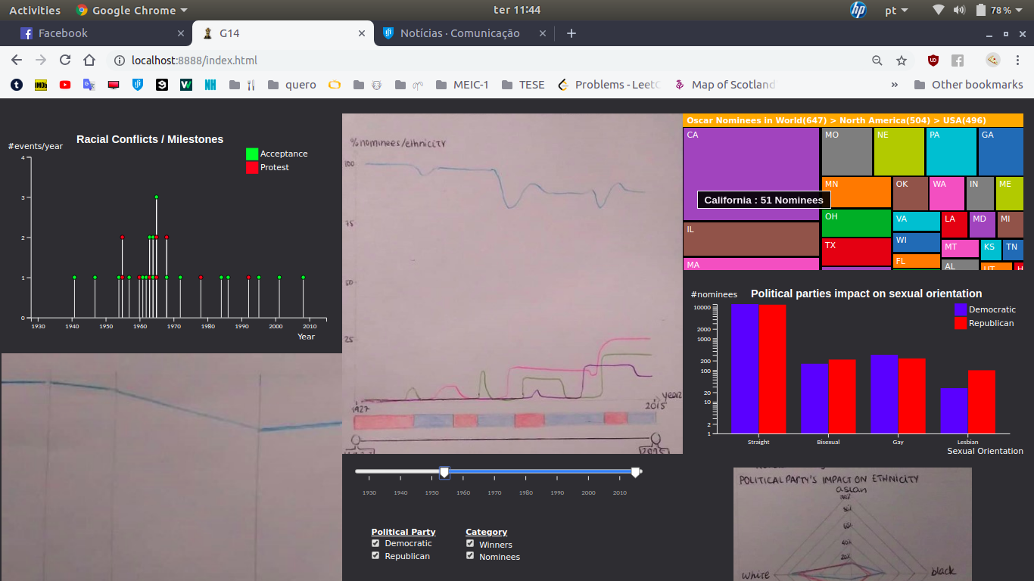  
Figure 10: Both parties selected - USA - mouse over on California

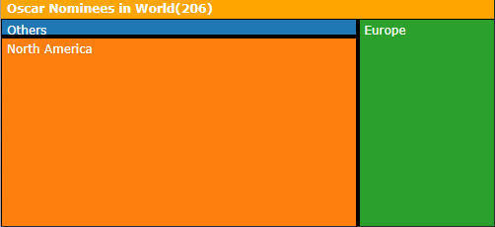  
Figure 9: Republican party selected - World

**3. Implementation of Linking Mechanism**

1. We have one file per idiom. Changes in one idiom affect the others through the use of **dispatch** and **custom events**. We have one dispatch and one custom event, “partyEvent”, which represents the change of political party. This event is used in all files, where in each file we add a namespace to the event name. This way, when the political party changes (*dispatch.call(“partyEvent”)*), all idioms react to it, through custom behaviour defined in *dispatch.on*.
2. When we have more idioms, for example the starplot, we just need to create a file corresponding to the new idiom and add the expression *dispatch.on(“partyEvent.starplot”, function(d){/*custom behaviour*/})* to the file corresponding to the starplot.

To make idioms “play well together”, we defined css classes, that style the axis, labels, legends, titles and text. This way, to style a newly added element, it is just necessary to add the class when developing the respective element.